Flow Cytometry Core (FCC): FACS Sort Request Form

A Chemical Biology of Infectious Disease (CBID) COBRE Core Laboratory

KU Flow Cytometry Core
1200 Sunnyside Ave
4006 Haworth Hall
Lawrence, KS 66045
https://fccl.ku.edu/

Peter R. McDonald
Core Manager
petemcd@ku.edu
(785) 864-1732

Robin C. Orozco
Scientific Advisor
orozco.robin@ku.edu
(785) 864-0345

P. Scott Hefty
CBID Director
pshefty@ku.edu
(785) 864-5392

This core facility is registered with the University of Kansas’ Department of Environment, Health & Safety (KU EHS) as a BSL-2 facility and has permission to perform cell sorts on non-fixed virus-infected specimens.

All specimens must be transported in accordance with KU EHS regulations. Specimens arriving from inside the Haworth building must be in a leak-proof primary receptacle (tube) in a sealed leak-proof secondary container. Specimens from outside of Haworth require triple layer packaging: a leak-proof primary receptacle (tube), a leak-proof secondary packaging, and an outer packaging box/cooler.

Unfixed specimens will be considered as potential biohazards and processed under BSL-2 requirements.

For all fixed specimens, appropriate and reliable methods must be used to inactivate potentially biohazardous agents (e.g. freshly prepared formalin solution: 1% for 30 min). These procedures must be performed CAREFULLY; otherwise, samples that are considered to be inactivated, but in fact are not, can pose a serious health risk to laboratory staff.

Rates

$50 set-up fee + hourly rate below:
KU Internal External Academic External Market
$22/h $34/h $66/h BD FACSymphony S6
$20/h $31/h $60/h BD FACSAria Fusion
$40/h $61/h $120/h Specialized service, labor

Policies

The FCC must be notified of any cancellations by 4:30 PM on the day prior to the sort date
or the investigator may be billed for the time he or she scheduled.

The sort request form must be given to the flow facility a minimum of 48 hours prior to the sort. The investigator must be accessible during the sort.
Cells should be filtered through a filter or cell strainer to remove cell aggregates. The following options for cell strainers fit into standard 15 mL and 50 mL conical tubes:
- 30μm, for 15mL tubes, Miltenyi Biotec MACS Pre-Separation Filter (cat. No. 130-041-407), $245/case of 50.
- 40 μm, for 15mL tubes, Fisher Scientific 07-001-106 EASYstrainer Cell Strainer, Greiner 542140, Green Sterile, 50/case filters, $115/case of 50.
- 40μm, for 50mL tubes, Fisher Scientific 07-000-222 EASYstrainer Cell Strainer, Greiner 542040, Green Sterile, 50/case filters, $115/case of 50.

Ideally, cells to be sorted should be suspended at a concentration of 5-10 million cells/mL in Ca and Mg free 1X PBS only. Lower cell concentrations are sometimes unavoidable but the concentration should not exceed 10 million cells/mL. Cells should be suspended in BD Falcon 5 mL round-bottom polystyrene tubes (cat. No. 352054) with no less than 500uL and no more than 3mL of sample per tube.

Bring appropriate control samples: Negative control, Positive control (if needed), Cells or antibody- capture beads stained as single color controls with each antibody used in your experiment.

If sorting into plates rather than tubes please bring enough plates for collection, plus one more for aligning the sort stream.
SORT REQUEST FORM
Investigator: ______________________________________ PI: __________________________________________
Email: ___________________________________________ Phone: ______________________________________
Sort Date: ______________________ Time Preferred: ____________________ Number of Samples: ______________
COMS / IBC registration number and title (for recombinant material and infectious agents):
__________________________________________________________________________________________________
IRB protocol number (for human specimens, if applicable): ________________________________________________
IACUC protocol number (for animal specimens): _________________________________________________________
Biosafety Level of this experiment (listed in COMS/IBC registration): ________________________________________
Grant code / PO # (if applicable): _____________________________________________________________________

1. List Type of sample: _____________________________________________________________________________
a. Eukaryotic cells (check one)
i. Human Rodent
Transgenic/grafted (list donor & host species): _______________________________________
Other: ___________
ii. Description: Cultured cells Freshly isolated primary cells Cell line (ATCC#)____________
Blood Primary cells Other: _______________________

b. Bacterial cells: ATCC#________________________________

2. Will the sample be fixed before delivery to the sorting facility? No Yes
If Yes: list the fixation agent, it’s concentration and the exposure time: ____________________________________

3. Have the samples been exposed to, or contain any infectious agents?
- No
- Yes (Describe): _____________________________________________________________________________

4. If samples are of human origin, have they been screened?
- No
- Yes – Describe: _____________________________________________________________________________

5. Does the sample contain any recombinant genetic material? Have the samples been genetically modified?
- No
- Yes – Describe vector (adenovirus, retrovirus, lentivirus, replication competent/defective, tropism, oncogenes), recombinant construct, gene inserts (HIV/SIV inserts etc), ecotropic, amphotropic, days after infection, etc:
___________________________________________________________________________________________

6. Are there any hazardous agents in your sample or collection media that the sort operator should be aware of?
- No
- Yes – Describe: __________________________________________________________________________

Sort Information
- Description of your experiment (in relation to flow cytometry):

- Number of cells per tube(s): Approximate % of sort population in sample(s): Number of target cells to be collected:

- Are the cells adherent?
- No
- Yes (refer to protocol for sorting live adherent cells: trypsin should not be used as it reduces expression of cell surface markers.)

- List all fluorochromes and markers used, including viability dye, or fluorophore panel with associated markers (if applicable). Laser configurations for the BD FACSAria Fusion and the BD FACSymphony S6 are on the following pages. E.g., matching laser to antigen to available channels / exemplary dyes; different configurations on each instrument.

- Please provide the FCC sort operator with 2x the expected volume of collection media or sterile filtered FBS.

- Provide details of gating strategy. If possible/necessary, please draw or copy-paste the gating strategy you would like the FCC sort operator to use for sorting your sample, including:
- Make sure your gating hierarchy and sort gates are clearly shown in your design.
- Indicate the populations to be collected.
- Provide details of expected % for each population, if known.
- Number of cells to be collected per population: _________________________
- Controls provided:
Unstained control
Individually labelled fluorophores / single stains
FMO: Fluorescence Minus One controls
+/- Positive/negative, activated/inactivated, etc
Compensation controls
Isotype control (an antibody selected as a negative control for flow cytometry experiments, and is used to detect non-specific binding)
Other controls: _______________
- Type of sort: Bulk Single Sort
- Collection vessel: 15mL tube FACS tube 1.5mL microtube slides (std / frosted) Multiwell plate: 6-well 12-well 24-well 48-well 96-well 384-well
- Temperature of samples during sorting: RT 4°C 37°C other _______
- Temperature of collection tubes/plates: RT 4°C 37°C other _______
- Sterile sort? Yes No
- Purity check required? Yes No
- Cell Diameter: _____________µm
- Collection media/FBS/PBS/other (see guidelines): _________________
- Other cell details, e.g. cells are: Robust Fragile _________________
BD FACSymphony S6 – five laser
Panel / Fluorochromes to be used and the gating strategy:
Laser | Band | Fluorochrome | Target | Notes/ Gating
355 nm UV Laser | BUV396 (379/28)
355 nm UV Laser | BUV496 (450LP; 515/30)
355 nm UV Laser | BUV563 (550LP; 586/15)
355 nm UV Laser | BUV661 (635LP; 670/30)
355 nm UV Laser | BUV737 (690LP; 740/35)
355 nm UV Laser | BUV805 (770LP; 820/60)
405 nm Violet Laser | BV421 (410LP; 431/28)
405 nm Violet Laser | BV480 (450LP; 470/14)
405 nm Violet Laser | BV605 (600LP; 610/20)
405 nm Violet Laser | BV650 (635LP; 670/30)
405 nm Violet Laser | BV711 (690LP; 710/50)
405 nm Violet Laser | BV786 (750LP; 780/60)
488 nm Blue Laser | BB515 (505LP; 515/20)
488 nm Blue Laser | BB630 (600LP; 610/20)
488 nm Blue Laser | BB700 (690LP; 710/50)
488 nm Blue Laser | BB790 (770LP; 780/60)
561 nm Yellow-Green Laser | PE (570LP; 586/15)
561 nm Yellow-Green Laser | PE CF594/PE-Texas Red (600LP; 610/20)
561 nm Yellow-Green Laser | PE Cy5 (650LP; 670/30)
561 nm Yellow-Green Laser | PE Cy7 (750LP; 780/60)
637 nm Red Laser | APC (650LP; 670/30)
637 nm Red Laser | Alexa 700 (690LP; 710/50)
637 nm Red Laser | APC H7 (750LP; 780/60)
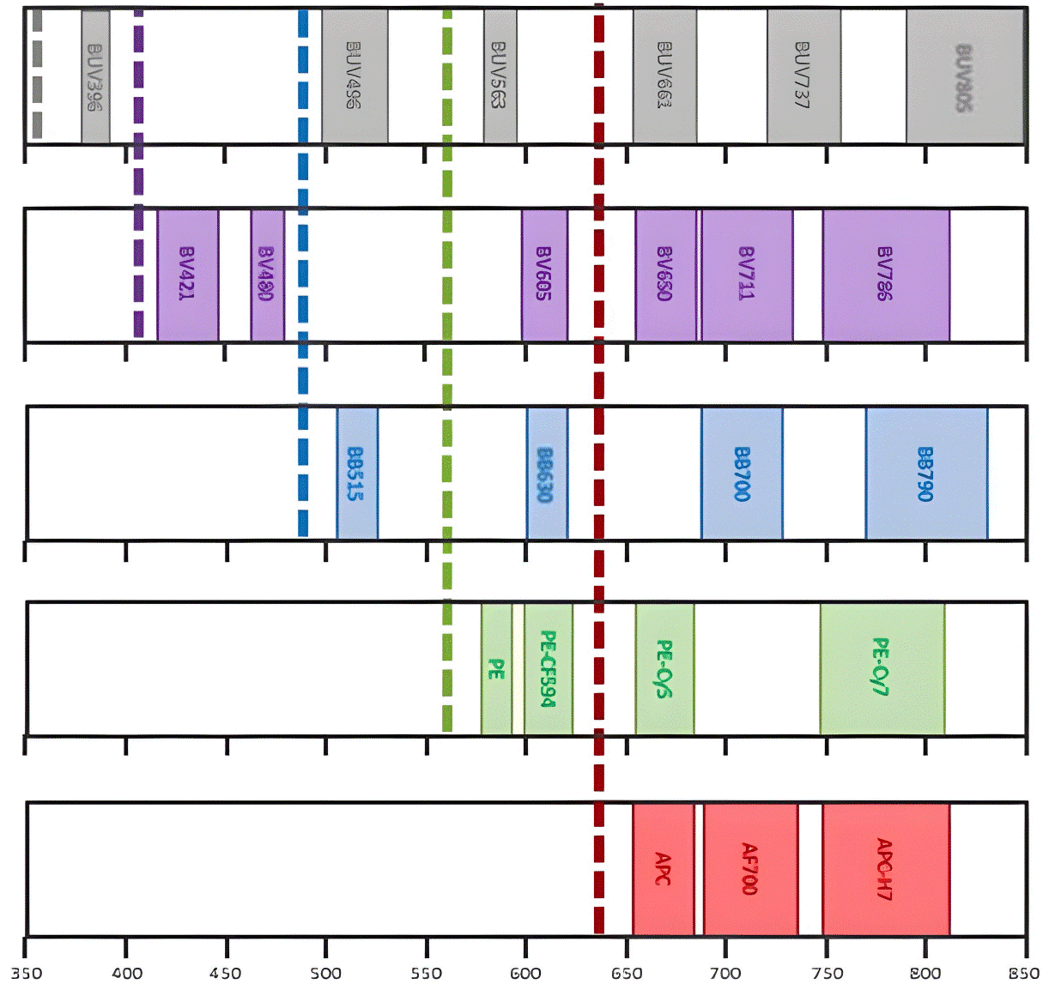

BD FACSymphony S6 Configuration
- Sort 6 populations simultaneously
- 355 nm UV Laser
- 405 nm Violet Laser
- 488 nm Blue Laser
- 561 nm Yellow-Green Laser
- 637 nm Red Laser
- Temperature controlled sorting
- 23-color sorter
- Includes BSC

BD FACSAria Fusion Configuration:
- Sort 4 populations simultaneously
- 405 nm Violet Laser
- 488 nm Blue Laser
- 561 nm Yellow-Green Laser
- 633 nm Red Laser
- Temperature controlled sorting
- 12-color sorter
Laser | Detector | 1o  Fluorochrome | Band Pass  Filter
405 nm 100 mW  Violet Laser | A | BD Horizon Brillian Violet | 421, V450
 | B | BD Horizon Brillian Violet | VPD450
 | C | Pacific Blue, DAPI | 450/40
 | D | Violet | 510 or V500
 | E | AmCyan | 525/50, 505LP
 | F | BD Horizon Brillian Violet | 605 (610/20, 595 LP)
 | G
 | H
488 nm 50 mW  Blue Laser | A | FSC
 | B | PerCP | 675/20
 | C | PerCP-Cy5.5 | 695/40
 | D | FITC/Alexa488 | 530/30, 502LP
 | E | SSC | 488/10
532 nm 150 mW  Yellow-Green Laser | A | PE/DsRed | 582/15
 | B | PE-Texas Red | 610/120, 600LP
 | C | mCherry | 610/120, 600LP
 | D | PI | 610/120, 600LP
 | E | PE-Cy5 | 670/14
 | F | PE-Cy5.5 | 710/50, 655LP
 | G
 | H
628 nm 200 mW  Red Laser | A | APC-Cy7 | 780/60, 735LP
 | B | Alexa 700 | 730/45
 | C | APC | 660/20

Cell populations to sort (collect) from the sample (up to 6 sub populations from each sample for Symphony, up to 4 for Aria Fusion):

BD FACSymphony S6 sorter: Sort 6 populations simultaneously

BD FACSAria Fusion sorter: Sort 4 populations simultaneously

No | Population ID | % of total | # To collect | Theoretical # needed | Markers/Phenotype
1
2
3
4
5
6

- Calculate theoretical # and recommended # of cells you need to start with: *Post staining and post filtering cell counts are the most accurate.
Recommended starting# (2x theoretical #) = ______________________________________________________

- Calculate the length of time for each sample: flow rate for medium sort is 6,000/sec, slow sort is 2,000/sec.
Time (Starting number / Flow rate per sample) = ___________________________________________________

- Sample concentration (Recommended: 5 to 25 million cells/ml): ________________________________

If possible, please provide your:
- Sample preparation protocol
- Staining protocol

Treating Adherent Cells for Live Sorting
  - Decant culture media off adherent cells. Add wash buffer to cells in a volume equal to the culture media volume: Wash Buffer: Ca and Mg free 1X PBS with 10% FBS. Swirl flask. Incubate 10 minutes at 37˚C. Swirl Flask. Decant off wash buffer.

  - After the final decanting step add EDTA buffer at a volume equal to one-tenth of the initial culture media volume: EDTA buffer: 2mM EDTA solution in Ca and Mg free 1X PBS with 10% FBS. Swirl flask. Incubate 10 minutes at 37˚C. Swirl Flask. Cells should now be in suspension.

  - Spin cells down and re-suspend in Sorting buffer at a concentration of 10 million cells per mL: Sorting buffer: Ca and Mg free 1X PBS, 1mM EDTA, 25mM HEPES pH 7.0 and one percent FBS : 2uM filter sterilize and store at 4˚C

  - If sorting into 96-well plates, add 100uL of Sorting Buffer with 10% FBS to every well. Increasing the FBS amount in the receiving buffer helps maintain cell viability.

Notes:

Divalent cations enable the cells to adhere; eliminating them in the buffering solution and adding a calcium chelator (EDTA) allows the cells to be placed in suspension.

Culture media is not an ideal sort buffer for several reasons:
- pH regulation fails under normal atmospheric conditions.
- The calcium chloride in most culture media is not compatible with the phosphate component of the instrument sheath leading to precipitation of calcium phosphate crystals.
- Phenol Red, included in many culture medias, contributes to background fluorescence.

The sorting buffer should have minimal FBS/BSA/FCS – the addition of protein to a sort buffer increases the amount of distorting light scatter thus decreasing the sensitivity of the forward and side scatter signals.

Cells under go increased pressure prior to and during a sort; the partial pressure of CO₂ also increases and will reduce the pH of the solution unless it is adequately buffered. HEPES buffer has an optimal buffering capacity at physiological pH. A final concentration of HEPES in a sort buffer with a neutral pH minimizes the acidification of the sample while under pressure.

